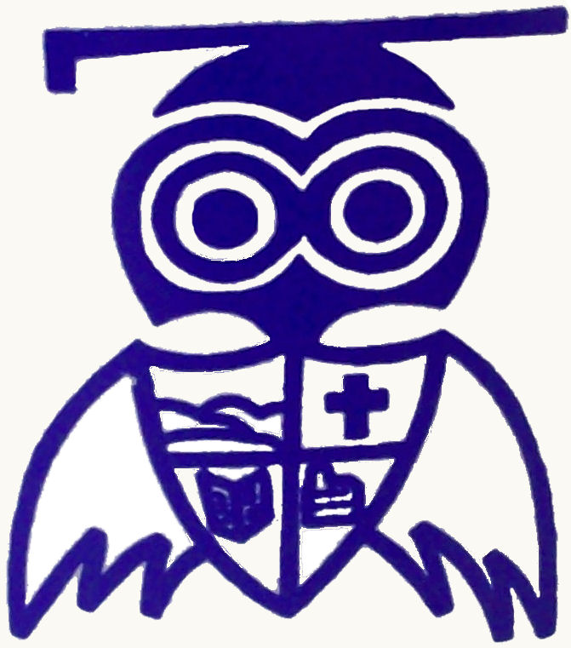
Wednesday 9th January 2013

Dear Parents / Carers,

Happy New Year
As we are now progressing through our first week of the spring term, may I take this opportunity to welcome everyone back and wish you all a very ‘Happy New Year’.

At the start of the new term I would also like to pass on a few reminders about policies and procedures at Eastlea:

1. School uniform
The vast majority of our pupils have returned to school looking very smart and tidy in their Eastlea school uniform. However, there are some instances where their footwear is causing some concerns. May I remind you that trainers are not to be worn in school and high heeled boots are also unsafe. Children should be wearing black school shoes. If the weather is particularly bad then boots could be brought into school to be changed into at breaks/lunchtimes but they are not suitable to be worn all day and must not have high heels as this is dangerous. Despite the recent milder weather, the winter months can still be cold and wet and to enable the children to keep warm and dry please could you ensure they have a suitable coat and perhaps gloves/hats/scarves as appropriate to be worn when they are outside.

2. P.E. kits
As always, please could you continue to remind the children to have their PE kit in school so that they can take part fully with the lessons that are going on – again items should be named and suitable footwear is required for outdoor sessions.

3. Jewellery
We have had far fewer issues this year with jewellery being worn in school – thank you for this. However, there remain a few instances where some children are getting their ears pierced during the school year. This causes problems as earrings cannot be worn in school. Please could you support us in only allowing ears to be pierced right at the start of the summer holiday so that the full 6 weeks can be given before earrings have to be removed.

4. Hair
Once again, thanks to your support we have had far fewer instances of children coming to school with inappropriate hairstyles this year. As you know, distinctively styled hair, designs shaved into the hair, shaved patterns and unnatural dyed hair should not be worn during term time.
In common with every other school, on occasion we do have issues arising in some classes with head lice. This then causes difficulties for the children concerned and unless everyone is vigilant it can be hard for families to ensure that their children remain clear of the problem. May I remind you that long hair must be tied back in school and hair should be thoroughly checked if problems with headlice occur – even when you think the infestation may be over.

5. Attendance and punctuality
Before the Christmas holiday I told you the latest information with regard to the weekly winners of our attendance and punctuality awards. Here are some further updates:
- Year 3 won our overall award for the best attendance for the second half of the autumn term – in total they won the weekly award 3 times during the half term – congratulations!
- Year 1 were awarded with a certificate for the best punctuality during the half term – well done!
- Despite the run of ill health which seemed to cause so many problems for a number of children in December, I am pleased to announce that 26 pupils were awarded with individual certificates for achieving 100% attendance in the autumn term
Attendance and punctuality will again be closely monitored this term together with support from the EWO. Competition remains fierce for our weekly attendance champions trophy and each class also wants to get their hands on the punctuality plaque – so your support in encouraging pupils to arrive in school on time every day is much appreciated.

6. Reading
Our magical reading challenge continues this term. Your continued support with reading at home to help your child climb the ‘rungs’ towards their bronze or silver awards is much appreciated. We hope to get more ‘faces’ on the ladders in the hall in the coming weeks! Further details of other events focused on reading will be sent out later this term.

Events planned for this half term
Here is an outline of all the many events and activities which are planned for the Eastlea pupils so far for the first half of the spring term...

What’s on | When and who?
Swimming sessions at Concordia | Monday mornings from 7th January (Year 4)
Attendance certificates and ‘light green’ letters are presented | Tuesday 8th January
‘Fiddles’ tuition – part of our continuing traditional music project | Wednesday afternoons in music lessons from 9th January  (Year 6 and Year 3)
Fiddles ensemble | Wednesday lunchtimes from 9th January  (Year 5)
Girls football coaching led by Amy Foggett | Monday afternoons from 14th January  (Year 5 and Year 6)
Lunchtime ‘Professional football coaching’ | Tuesday lunchtimes from 15th January  (pupils from Year 3, 4, 5 and 6)
New Nursery pupils join Eastlea | Tuesday 15th January
Lunchtime ICT clubs | Wednesday lunchtimes from 16th January  (pupils from Year 1, Year 3 and Year 4)
Governors – Resources committee meeting | Wednesday 16th January (5pm)
Lunchtime Running club | Thursday lunchtimes from 17th January – weather permitting! (Year 4)
Governors – School Improvement committee meeting | Thursday 17th January (4pm)
Thursday Lunchtime activities | Various clubs/activities for Year 5 and Year 6 to continue for pupils on Thursday lunchtimes from 17th January
After school ‘KS2 Eastlea Singing club’ | Starts again Wednesday 23rd January 3.15pm – 4.15pm  (pupils from Years 3, 4, 5 and 6)
Eye tests for Reception pupils | Thursday 31st January (Reception)
Writers workshop at Burnside | Wednesday 6th February  (Group of pupils from Year 5 and Year 6)
Handball competition at Concordia | Friday 8th February  (Group of pupils from Year 6)
Chinese New Year assembly and activities | Tuesday 12th February
Golden Day | Thursday 14th February  (all pupils who have followed our behaviour policy)
Pupils break up for half term | Friday 15th February
School reopens after the half term holiday | Monday 25th February

Advance notice for parents of pupils in Year 6
Mrs Coleby has asked me to mention that the KS2 SATs week this year takes place in the week beginning May 13th 2013. Ever since Eastlea became a Primary school our Year 6 pupils have done us proud with their efforts in this important week and I know that this year will be no exception. Arrangements for some of the SATs have altered again this year – thanks to the ever changing government agenda – but in order to ‘show off’ what they can do it is vital that all the Year 6 pupils are in school every day that week, so I hope that this advance notice of the date is helpful.

Yours sincerely

E Beeston

Miss E Beeston
Head Teacher

