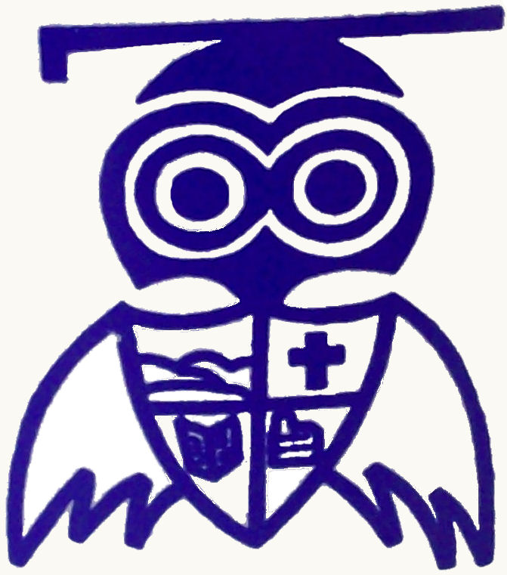
Eastlea Primary School
Permission for school visits and food tasting 2024-25
We will continue to offer school visits this year to enrich our curriculum as well as encouraging participation in as wide a range of activities as possible. So that we have the correct ‘permissions’ in place, please add the name of your child then tick the appropriate boxes below and ensure you sign and date the bottom of the form – thank you!

Name of child: .............................................................. Class: .............................
School visits
I give permission for my child to take part in planned visits out of school for the school year 2024-25 and will keep school informed of changes to medical information

Food tasting
I give permission for my child to taste food as part of their work in school for the school year 2024-25

OR

My child is allergic to / has an intolerance to:

However they may taste other foods as part of the sessions

My child cannot eat the following foods due to our religion / culture / belief:

However they may taste other foods as part of the sessions

I confirm the permissions indicated and agree to inform the school if there are any changes to the above

Signed: ........................................................................... Date: ...............................

